**Nueral Networks & Deep Learning**

**Assignment – 1**

**Name :** Ajay Mohan Reddy Veluru

**Id :** 700740836

Que 1

*Given string python as a list of character and I have deleted three characters and reversed them and the result is typ

*Two input intergers given by the user and performed four arithmetic operations.

Que 2

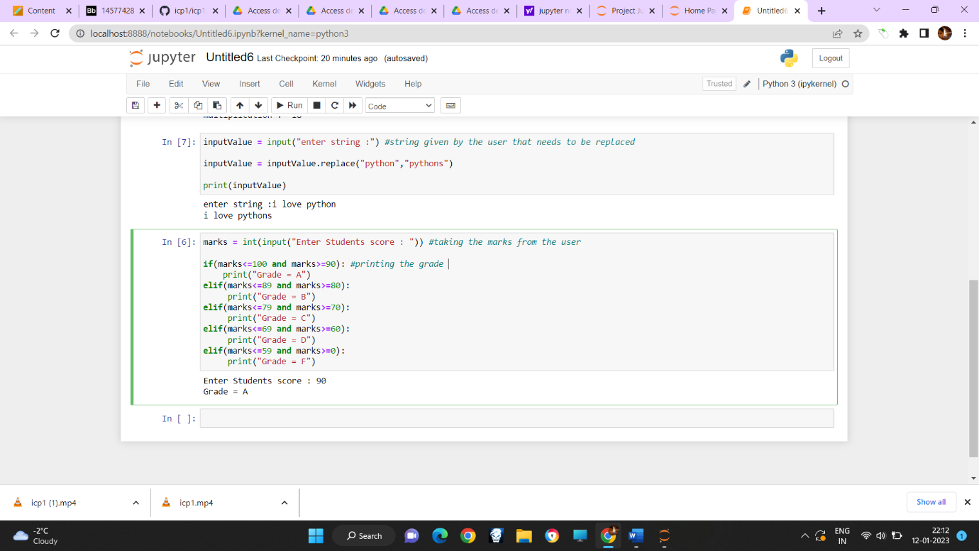*Considering the sentence containing the term python and replacing it with pythons.

*using if else method in order to differentiate the grades according to the marks scored by the students. Student enters his marks as a input and his grade will be displayed as an output.

Github Link: <https://github.com/Ajay-Reddy564/Nn-Dl-Assignment1>

Video Link: <https://www.loom.com/share/bb49ec1359624ee5aa39df9cb9fe655f>